 | 12.1.55 Editors - Geometry Nodes Editor - Header - Add Menu - Hair - Generation
Table of content
Detailed table of content 1
Add menu - Hair - Generation 2
Duplicate Hair Curves 3
Generate Hair Curves 4
Interpolate Hair Curves 5

Detailed table of content

Table of content
Detailed table of content 1
Add menu - Hair - Generation 2
Duplicate Hair Curves 3
Input 3
Geometry 3
Amount 3
Viewport Amount 3
Radius 3
Distribution Shape 3
Tip Roundness 3
Even Thickness 3
Seed 3
Output 3
Geometry 3
Guide Index 3
Generate Hair Curves 4
Input 4
Surface 4
Surface Object 4
Surface UV map 4
Surface Rest Position 4
Hair Length 4
Hair Material 4
Control Points 4
Poisson Disk Distribution 4
Density 4
Density Mask 4
Mask Texture 4
Viewport Amount 4
Seed 4
Output 5
Geometry 5
Curves 5
Surface Normal 5
Interpolate Hair Curves 5
Input 5
Guide Curves 5
Surface Geometry 5
Surface Object 5
Surface UV map 5
Surface Rest Position 5
Follow Surface Normal 5
Part by Mesh Islands 5
Interpolation Guides 5
Distance to Guides 5
Poisson Disk Distribution 6
Density 6
Density Mask 6
Mask Texture 6
Viewport Amount 6
Seed 6
Output 6
Geometry 6
Guide Index 6
Surface Normal 6

Add menu - Hair - Generation

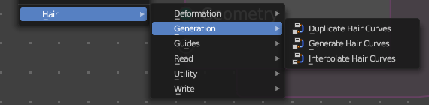
Hair nodes are Node Groups found in the Essentials Library included with Bforartists. They differ from the other nodes in the add menu due to being mid level node groups instead of individual low level nodes.
You can enter the node tree by clicking at the icon up right. Tab to leave the node tree. And you can of course also edit the node tree.



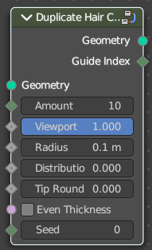
Duplicate Hair Curves
Duplicates hair curves a certain amouunt of times in the given radius.

Input

Geometry
The input geometry.

Amount
Amount of duplication per curve.

Viewport Amount
How much percent is used in the viewport.

Radius
The radius in which the duplicate curves are offset from the guides.

Distribution Shape
Shape of distriubution from center to the edge aroudn the guide.

Tip Roundness
Offset of the curves to round the tip.

Even Thickness
Keep an even thickness of the distribution of duplicates.

Seed
Random seed for the operation.

Output

Geometry
The output geometry.

Guide Index
The guide index map that was used for the operation.

Generate Hair Curves
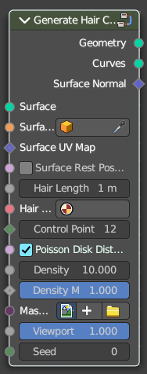
Generates new hair curves on a surface mesh.

Input

Surface
The surface to generate the hairs on.

Surface Object
A surface object to generate the hairs on.

Surface UV map
Surface UV map used for attachment.

Surface Rest Position
Set the surface mesh into its rest position before attachment.

Hair Length
Length of the generated hair curves.

Hair Material
The material for the hair curves.

Control Points
Amount of control points for the generated hair curves.

Poisson Disk Distribution
Use Poisson Disk distribution to keep a minimum distance between the hair curves.

Density
How dense the generated hair curves are.

Density Mask
Factor for the density of generated hair curves.

Mask Texture
Discard points based on a mask texture after distribution. This mask can be loaded here.

Viewport Amount
How dense the generated hair curves are displayed in the viewport.

Seed
Random seed for operation.

Output

Geometry
The output geometry.

Curves
The output curves.

Surface Normal
The surface normals.

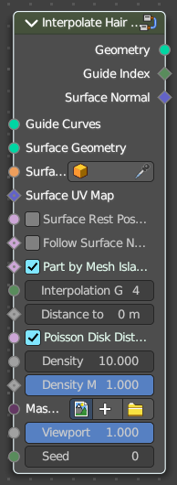
Interpolate Hair Curves
Interpolates existing guide curves on a surface.

Input

Guide Curves
Input guide curves.

Surface Geometry
The surface geometry to generate the hairs on.

Surface Object
A surface object to generate the hairs on.

Surface UV map
Surface UV map used for attachment.

Surface Rest Position
Set the surface mesh into its rest position before attachment.

Follow Surface Normal
Align the interpolated curves to the surface normal.

Part by Mesh Islands
Use mesh islands of the surface geometry for painting.

Interpolation Guides
Amount of guides to be used for interploation per curve.

Distance to Guides
Distance aorund each guide to spawn interpollated curves.

Poisson Disk Distribution
Use Poisson Disk distribution to keep a minimum distance between the hair curves.

Density
How dense the generated hair curves are.

Density Mask
Factor for the density of generated hair curves.

Mask Texture
Discard points based on a mask texture after distribution. This mask can be loaded here.

Viewport Amount
How dense the generated hair curves are displayed in the viewport.

Seed
Random seed for operation.

Output

Geometry
The output geometry.

Guide Index
The output curves.

Surface Normal
The surface normals.

